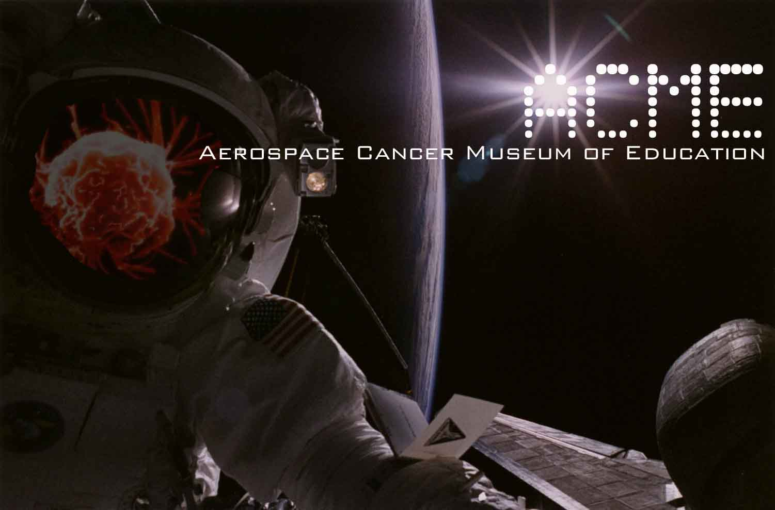

Mr. Paul Davis 5/5/2008
City of Los Angeles Department of Parks and Recreation
1200 West 7th Street, Suite 700
Los Angeles, California 90017
(Via e-mail)

RE: BFI and the Chatsworth Reservoir

Dear Mr. Davis,

As a business owner of Chatsworth Lake Manor, I am concerned about the Current grading and re-trenching that is currently going on without any DTSC oversight or air-monitoring equipment. Also the removal of 500 feet of concrete channel in the Chatsworth Reservoir is a big mistake. This channel diverts the toxic runoff from Woolsey and Box Canyons into a tunnel which drains directly into the Los Angeles River watershed at Roscoe and Lena Avenue.

The Environmental Impact Report makes no mention of the Santa Susana Field Laboratory, THIS IS WHY THE 500 FT CONCRETE CHANNEL WAS BUILT, TO KEEP RUNOFF FROM THE SSFL OUT OF THE DRINKING WATER SUPPLY. The SSFL was home to 10 experimental nuclear reactors, a large nuclear meltdown; nuclear experiments, thousands of rocket tests, and groundwater plumes of half a million gallons of TCE and other chemicals. The SSFL is 1,000 feet above the valley floor and drains directly into the Chatsworth Reservoir. Recently we found that it qualifies as a Superfund Site. The EIR makes no mention of the community of Hidden Lake and what kind of impact the changes will have on the already high water table in this area.

There are higher rates of cancers in this area according to a 2006 UCLA study.

There needs to be more community meetings and another comment period.

If there are any questions I can answer please call…310-428-5085.

Take care,

William Preston Bowling
ACME (Aerospace Cancer Museum of Education)
williamprestonbowling@yahoo.com
www.ACMELA.org
310.428.5085
http://www.ACMEla.org
23350 Lake Manor Drive
Chatsworth, California 91311

