

Norm Riley 5/13/2008
9211 Oakdale Avenue
Chatsworth, CA 91311 (Via U.S. Mail and E-mail)

Dear Mr. Riley,

Dear Norm,

Action Needs to Be Taken TODAY!!!

After my request to you was forwarded to Susan Callery, as per her advice I sent a complaint to DTSC via their online service. I have had no response. I have even left phone messages with my Complaint Record Number: 4164.

It has been almost a month.

This is an issue of Explosives!!!

This is a not a joke, this is an explosive device found on train tracks. THERE COULD BE MORE!!! How will we know for certain if there is no follow up?

IT HAS BEEN ALMOST A MONTH!!!

THIS IS A ROCKETDYNE ISSUE!!! (Read Below)

Below is my full report with complaint number I presented to DTSC.

I did not take this to the Media or any high-ranking Government officials, as that is not my style, I work things out like a gentleman. Since it has been almost 30 days with no action, I feel that making this public is the only way to get this taken care of.

This e-mail will be sent to the media and public officials.

Without even a phone call from anyone at DTSC asking me anything about this EXPLOSIVE DEVICE FOUND ON THE TRAIN TRACKS, is a great concern to what DTSC is doing to look out for the community.

Ventura County Fire had to STOP AN AMTRAK PASSENGER TRAIN.

THIS IS A BIG DEAL!!! I cannot say this enough.

I need this looked into NOW!!!

William Preston Bowling
Founder ACME
Aerospace Cancer Museum of Education
23350 Lake Manor Drive
Chatsworth, California 91311
http://www.ACMEla.org

Attached please find photos of the incident.

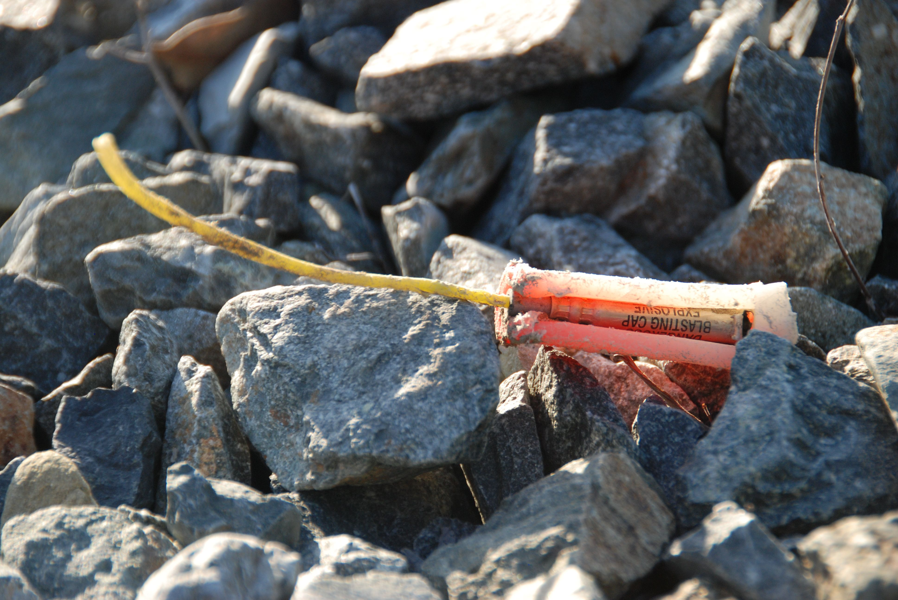

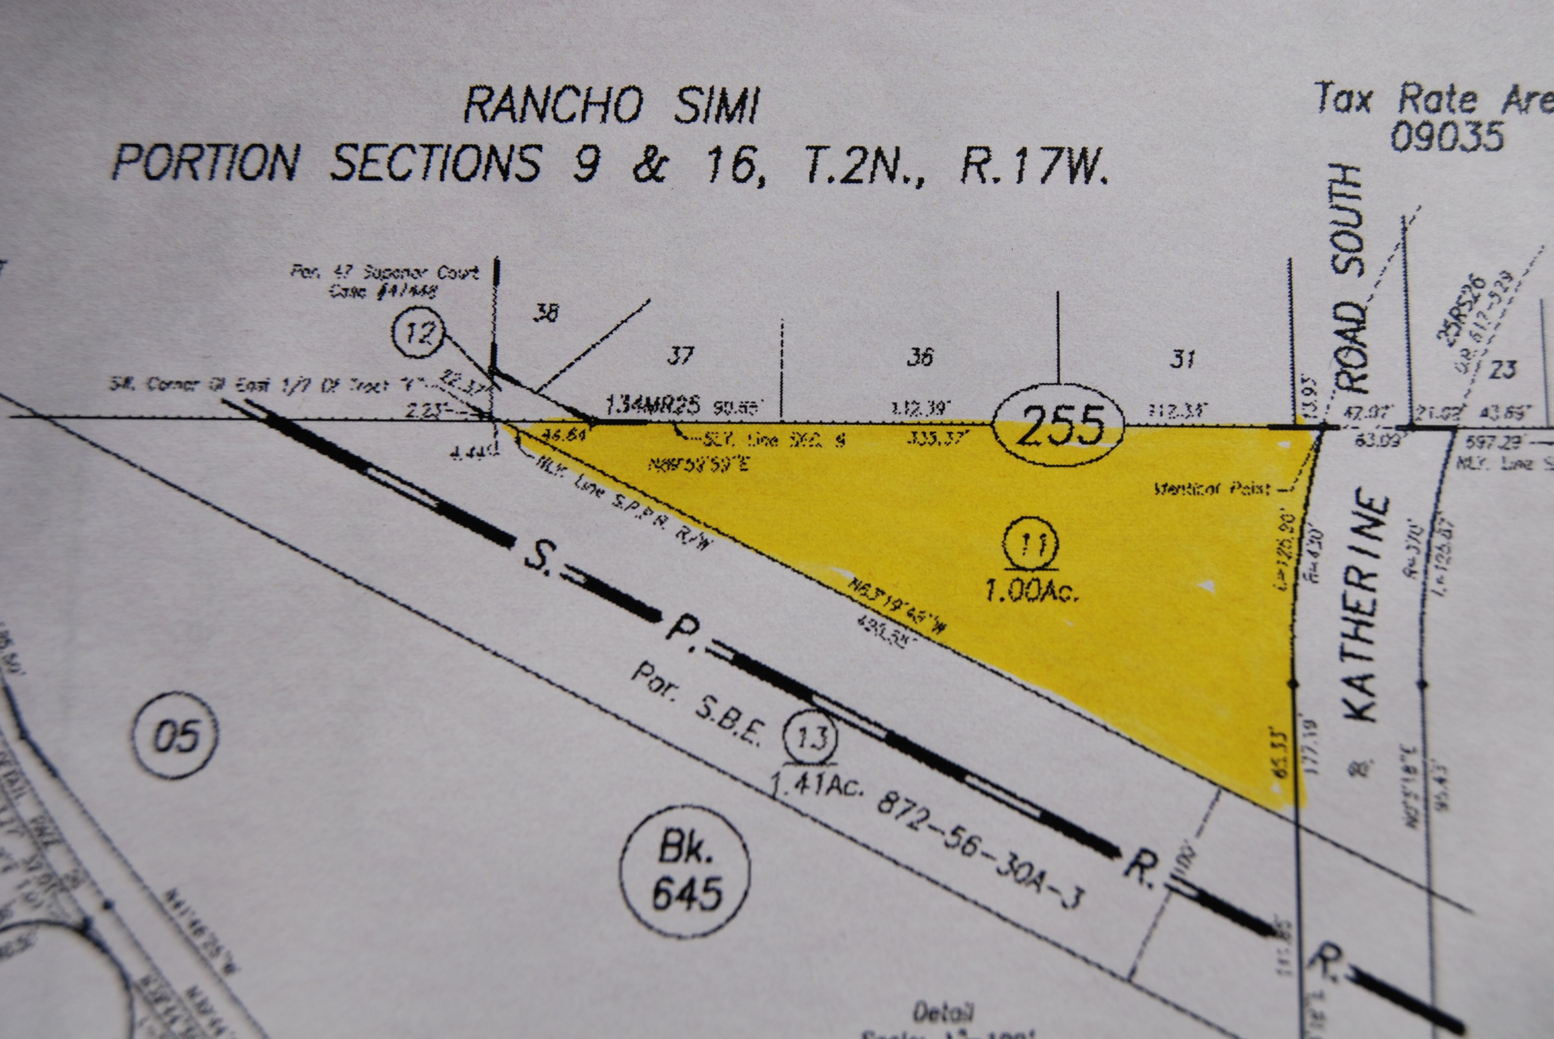

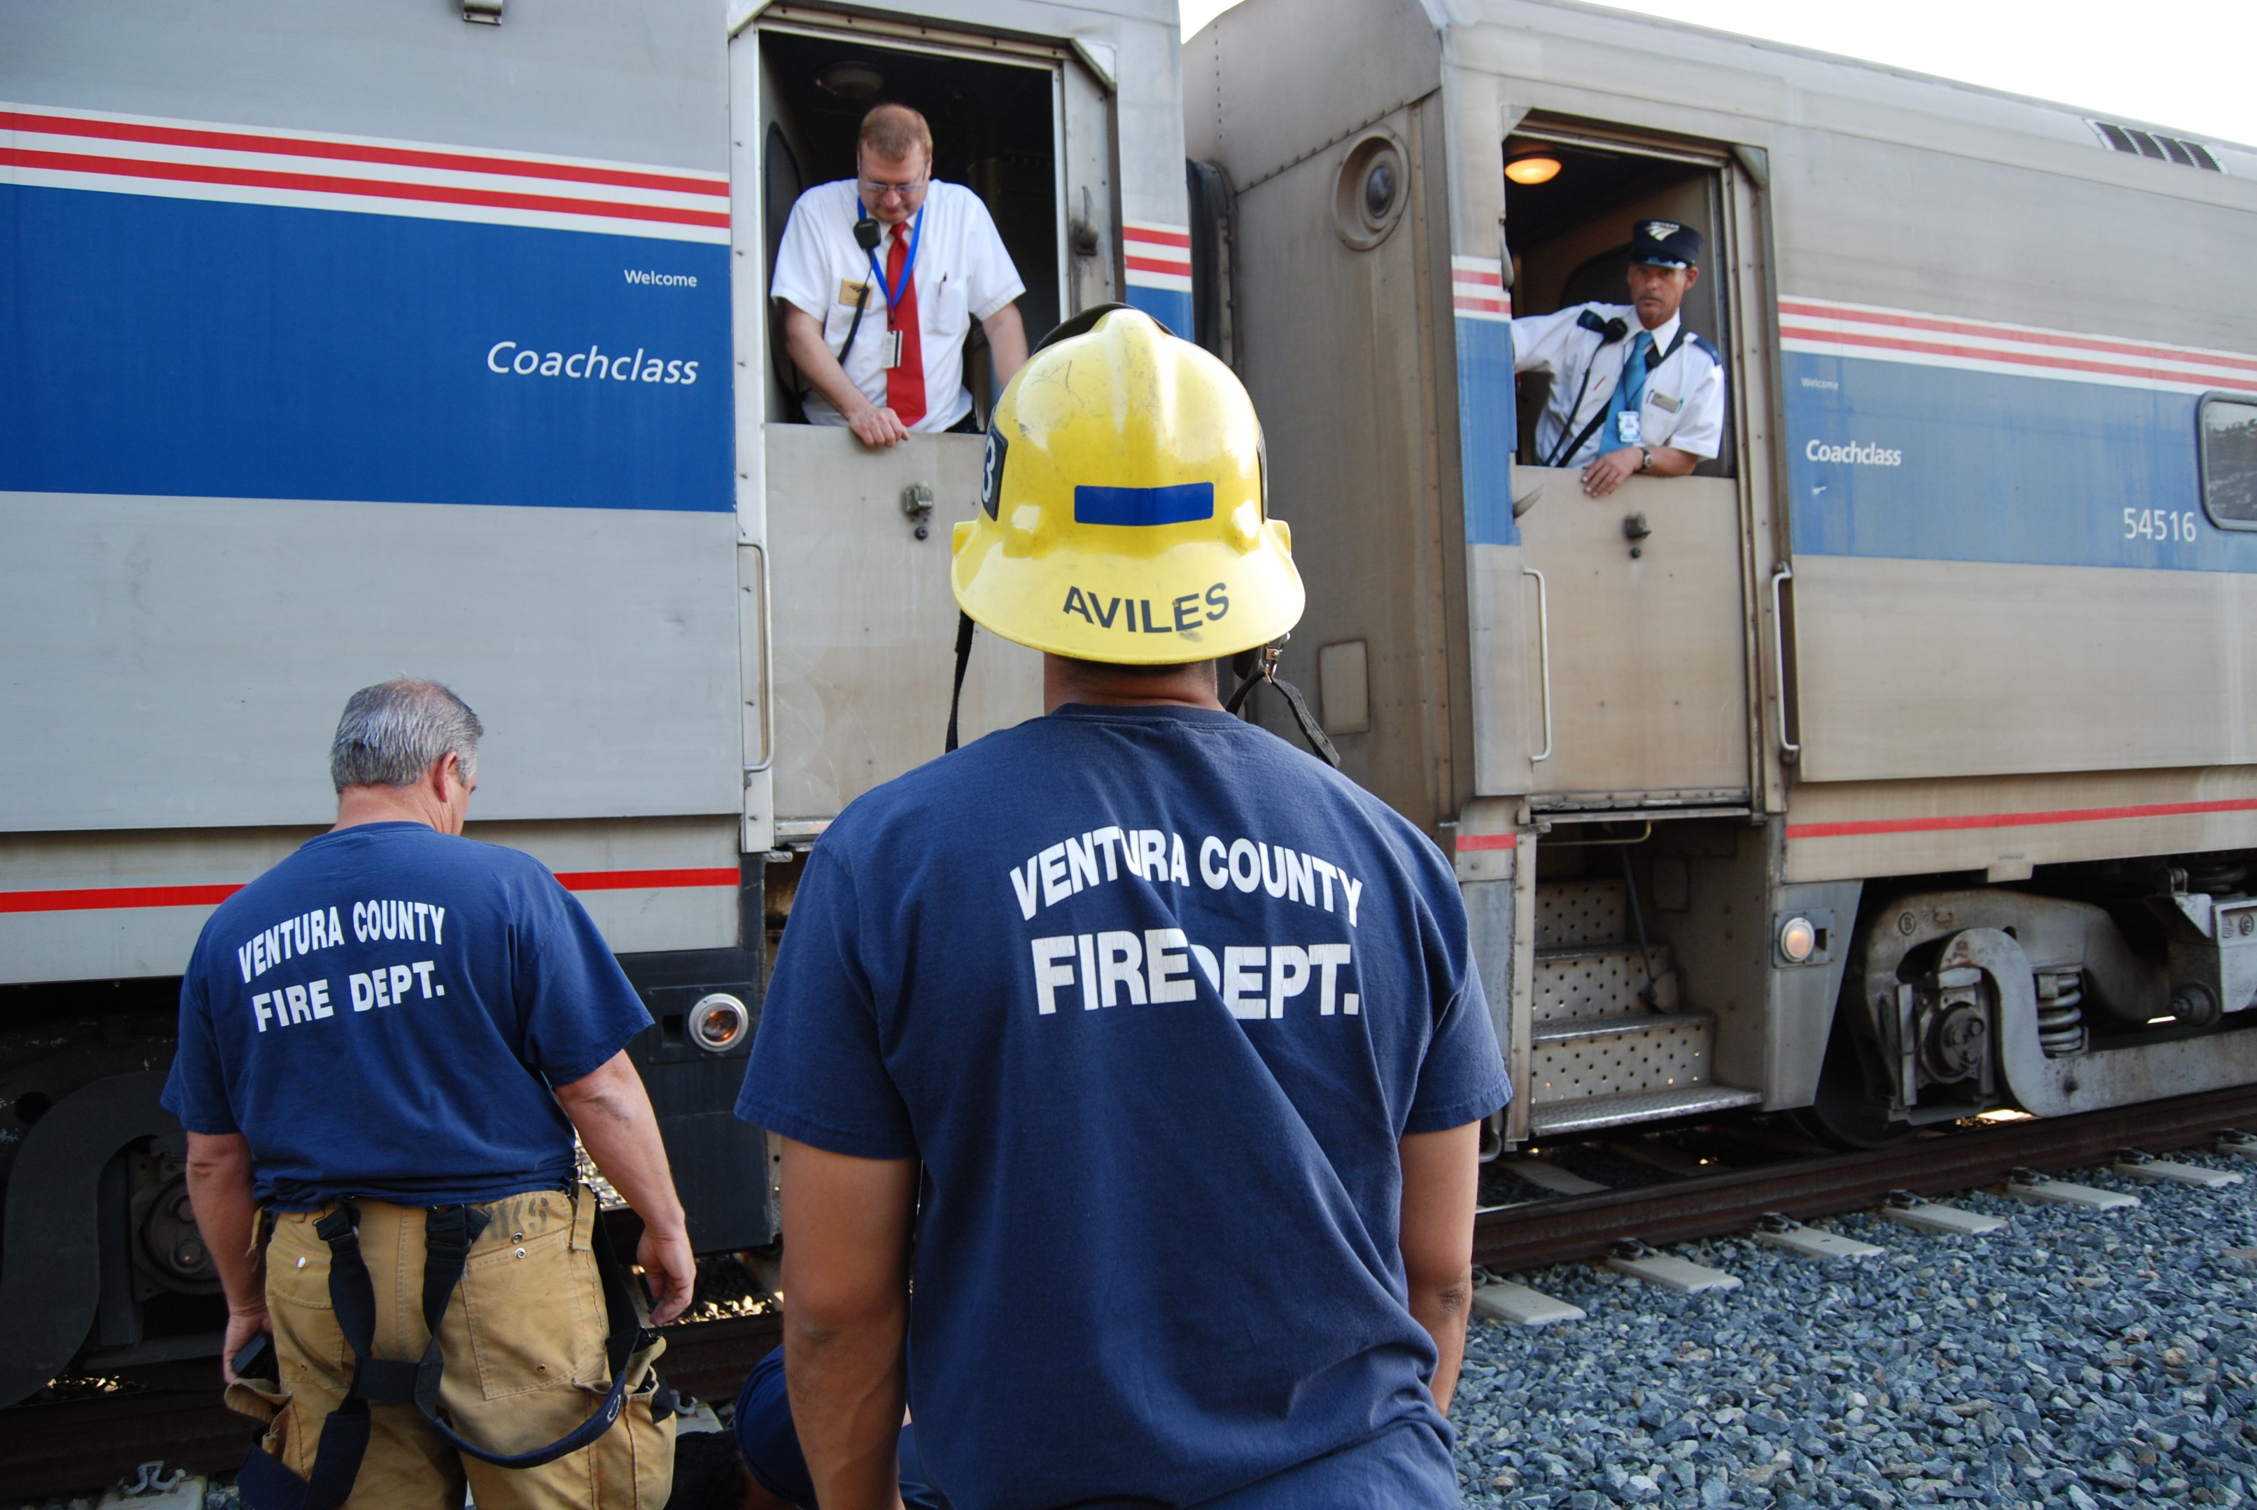

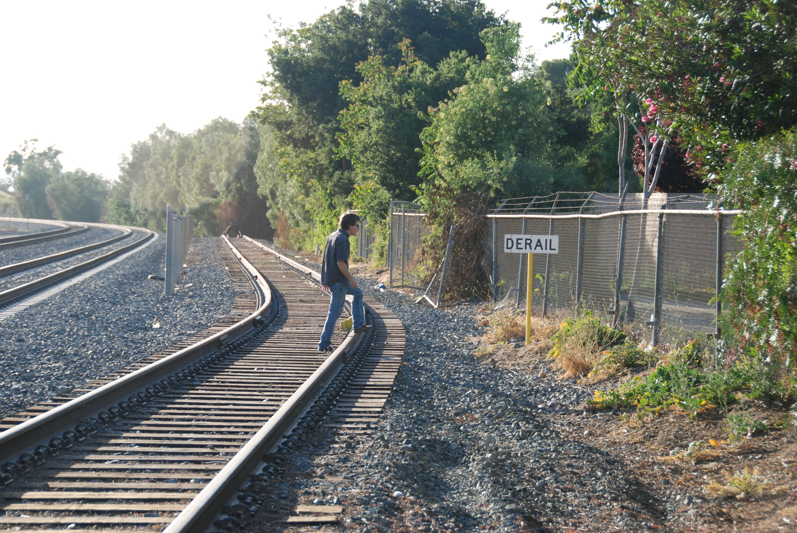

Cal/EPA Environmental Complaint Form - Receipt

Complaint Record Number: 4164

Thank you for submitting your complaint to Cal/EPA. Your complaint was received on 4/19/2008 at 11:15 AM and has been assigned Complaint Record Number: 4164. Cal/EPA staff will assess this complaint and will investigate, inspect or refer the complaint information to another agency as appropriate. Cal/EPA recommends that you print and keep this receipt for your records.

Name: William Preston Bowling
Address: 23350 Lake Manor Drive
City, St. ZIP: Chatsworth, CA 91311
Phone Number: (310)428-5085
E-Mail: williamprestonbowling@yahoo.com

Complaint Information:
Complaint Address or Location Description
Address: Katherine Street and Train Tracks
City, St. ZIP: Simi Valley , CA
County: VENTURA
Location Description: On the Train Tracks just West of Katherine Street in Simi Valley.

Alleged Responsible Party
Name: The Boeing Co.
Address: 5800 Woolsey Canyon Road
City, St. ZIP: Canoga Park CA 91304
Phone Number (818)466-8793

Related To: Toxic Substances

Date of Occurrence: 04/17/2008 Time: 6:00 PM Ongoing: Unknown
Complaint Description:
Christina Walsh and I headed
over Black Canyon, Past Rocketdyne from our office in
Chatsworth to attend the Stormwater Expert Panel
meeting regarding the SSFL.

I obtained some information that Rocketdyne had a
"Spur" off Katherine Street in Simi Valley. I wanted
to show this area to Ms. Walsh on our way to the
meeting.

A "Spur" is a "Dead-End" railway with a bumper at the
end of the track. These are used for Loading and
Un-loading.

While we were photographing the area we came across a
device that looked like a small stick of dynamite. I
picked it up and when I read the word "Blasting Cap"
on it's side, I slowly laid it back down.

The Cap was covered by some sort of plastic cover, I
thought maybe it was wrapped with a type of plastic
explosive to increase the charge of the blasting cap.

We could not go to our meeting and just leave it there
for a child to find.

We went to the closest Ventura County Fire Department
and told them of our find.

They alerted the rail line to stop any trains passing
through and they alerted the bomb squad.

We took them to the location and pointed out the
device. At this moment an Amtrak Passenger train
filled with onlookers stopped on the exact spot where
the device was found (See Attached Photos).

The Fire Cheif said that this area was used by
Rocketdyne for Loading and unloading Helium, therefore
confirm our investigation. I asked if this was
leftover from that era and he was not sure.

This area needs to be looked into by the DTSC and other
agencies to ensure the safety of the surrounding
communities as there was a Little League Game going on
within 100 feet of this device

Take care,

William Preston Bowling

Aerospace Cancer Museum of Education
23350 Lake Manor Drive
Chatsworth, California 91311
http://www.ACMEla.org

ACME the Aerospace Cancer Museum of Education, Los Angeles Chapter. ACME -
Educating the Public of Neighboring Aerospace Industry Toxins through the Arts.
ACME – Aerospace Cancer Museum of Education
is in affiliation with International Humanities Center
http://www.ihcenter.org/groups/
acmela.html , a nonprofit public charity exempt from federal income tax under
Section
501c(3) of the Internal Revenue Code. It is people like YOU that keep these
websites in
operation. Your donations are greatly appreciated.

Other links of interest on this subject…

http://www.CleanUpRocketdyne.org
http://www.SSFLPanel.org
http://www.RocketdyneArchives.com
http://www.CommitteeToBridgeTheGap.org
http://www.RocketdyneWatch.org
http://www.StopRunkleDyne.com
http://www.The-Aero-Space.com
http://www.EnviroReporter.com
http://www.H2ohno.com
http://www.PSRLA.org

Please Consider the Environment Before Printing this E-mail

CONFIDENTIAL AND PRIVILEGED COMMUNICATION: This e-mail transmission, and any
documents, files or previous e-mail messages attached to it, may contain
confidential
information that is legally privileged or otherwise inadvertently disclosed to
you. If you
are not the intended recipient, or person responsible for delivering it to the
intended
recipient, or person responsible for delivering it to the intended recipient,
you are hereby
notified that any review, disclosure, copying, distribution, or other use of any
of the
information contained in or attached to this message is STRICTLY PROHIBITED.
Interception of e-mail is a crime under the Electronic Communications Privacy
Act, 18
U.S.C. 2510-2521 and 2701-2709. If you have received this transmission in
error, please
immediately notify myself or my assistant by replying to this e-mail or by
telephone at
310.428.5085, and destroy the original transmission and its attachments without
reading
them or saving them in any format. "The sender believes that this E-mail and any
attachments were free of any
virus, worm, Trojan horse, and/or malicious code when sent. This message
and its attachments could have been infected during transmission. By
reading the message and opening any attachments, the recipient accepts full
responsibility for taking protective and remedial action about viruses and
other defects. The sender's employer is not liable for any loss or damage
arising in any way from this message or its attachments."

